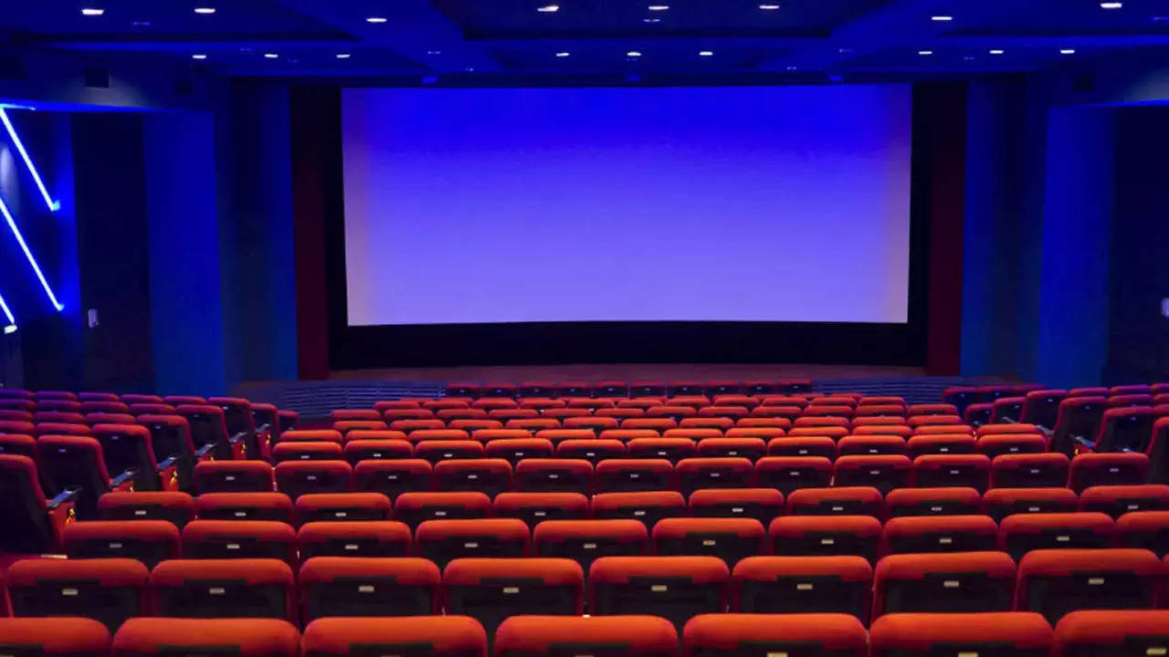

Cinema Booking System
  - Programming final project
  - Report.



Submitted to:
Sir Harris.
Submitted by:
Zowrays Hassan (CS-26)
Ali Abbas Shah (CS-11)
Azhar Ali (CS-14)
Deadline:
6/9/24.
Lab Report: Cinema Booking System
- Objective
The objective of this lab is to develop a comprehensive cinema booking system in C++ that allows users to:
- Selection of Movies, Concert and Plays.
- Selection According to Genre, Dates and Prices.
- Book seats and snacks.
- Premium and Standard Seats
- View Reserved Seats
- Change Reserved Seats
- Loyalty program
- Get a receipt.
- Provide feedback and exit the program.
- Theory
Cinema booking systems are essential for managing reservations, seating arrangements, and customer interactions in theatres. These systems enhance user experience by allowing customers to select seats, change reservations, book snacks, and receive detailed receipts. Additionally, gathering user feedback helps improve system functionality.

Key Concepts
- Arrays: Used to represent seating arrangements.
- Loops: Employed to manage user interactions and repeat operations.
- Functions: Modularize the code for clarity and reusability.
- Conditionals: Control the flow based on user inputs.
- Input/Output Operations: Handle user data and display necessary information.
- Methodology
The cinema booking system was developed using the C++ programming language. The program features a menu-driven interface that allows users to perform various actions related to seat reservations and snack booking. Key functionalities include viewing seats, changing seats, generating receipts, booking snacks, and capturing user feedback.

System Design
- Main Menu: Displays options for users to select.
- Seating Arrays: Represent seats for movies, plays, and concerts.
- Function Calls: Handle specific tasks like displaying seats, booking seats, booking snacks, and generating receipts.
- Loop Control: Manages the continuation and exit conditions for the program.

Functions Implemented
- clearScreen (): Clears the console screen.
- display seats (): Displays the seating arrangement.
- initialize seats (): Initializes the seating arrangement.
- book_seats (): Allows users to book seats.
- receipt (): Generates a receipt for the user.
- display (), choices (), choice menu (): Manage user choices and display options.
- purchase snacks (): Handles snack purchases.

Logic and Implementation
The core logic of the program revolves around managing user interactions and seat reservations. Here's a breakdown of the main components and their roles:

Main Menu Loop
The main menu is displayed using a do-while loop that runs until the user decides to exit. Inside the loop, user input is taken to select different options:
- View Reserved Seats:
  - Displays the current reservation status.
  - Uses display seats () function based on the type of event (movie, play, concert).
- Change Reserved Seats:
  - Reinitializes and allows changing the seats.
  - Utilizes initialize seats () and book_seats () functions.
- Book Seats and Snacks:
  - Books seats and allows booking of snacks.
  - Uses book_seats () and purchase snacks () functions.
  - If the user wants to continue, it resets the booking details and reinitializes the seats.
- Get Receipt:
  - Generates and displays a receipt
  - Ask User Again to Continue the Program
- Exit:
  - Captures user feedback.
  - Exits the program gracefully.

Handling User Continuation
After each action (except exit), the program prompts the user to decide whether to continue or not. This is managed by a combination of conditionals and the toupper () function to handle user input case insensitivity.

Deliverables
- Source Code: The C++ program implementing the cinema booking system.
- Documentation: This lab report documenting the objective, theory, methodology, and results.
- Executable: Compiled version of the program (if applicable).
- Results
The cinema booking system successfully allows users to:
- View and manage seat reservations.
- Change reservations.
- Book seats and snacks.
- To get loyalty offer
- Receive a detailed receipt.
- Provide feedback.

